Tickets Menu:

When you select an item in the table, information populates text fields

You’re able to update the text fields by typing in them, and save the information by clicking the Update button. To create a ticket, type in the text fields and click the Create button. With manager access, after selecting a row in the table, click the Delete button to remove the ticket from the database. To exit, click the X button in the top right corner of the window. After this, all information is saved for the next time the ticket menu is opened.

Inventory Menu:

When you select a row in the table, the text fields populate

If you want to update an item’s information, type in the new information in the text fields and save by clicking the Update button. If you’re trying to create an item, you’ll need manager access. With that status, type in the new item’s information in all of the text fields and click the Create button. If you need to erase all fields, click the Clear Button. To delete an item, select the item in the table, and click the Delete button. When you exit the window, the information is saved for the next time the Inventory menu is opened.

Manager Menu:

Only managers have access to this menu. Select an employee in the table to populate their information in the fields. If you need to update an employee, type in their new information and click the Update button to save. If you need to create an employee, type in the information first and click Create. You’ll see the table update with their information. To delete a staff member, select them in the table and click the Delete button. When you leave the window the information is all saved for the next time the Manager menu is opened.

Purchase Menu:

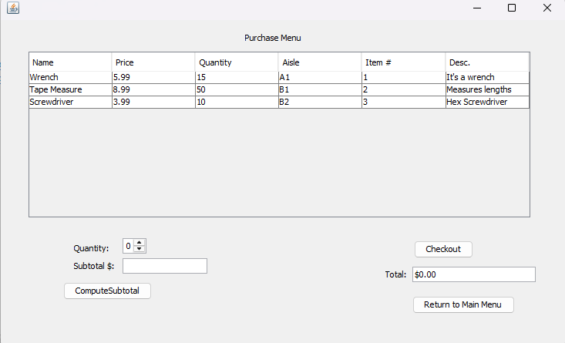

The purchase menu consists of the Inventory table which reads from the inventory csv file, a quantity spinner, a compute subtotal method, a checkout button, and a textfield that displays a total.

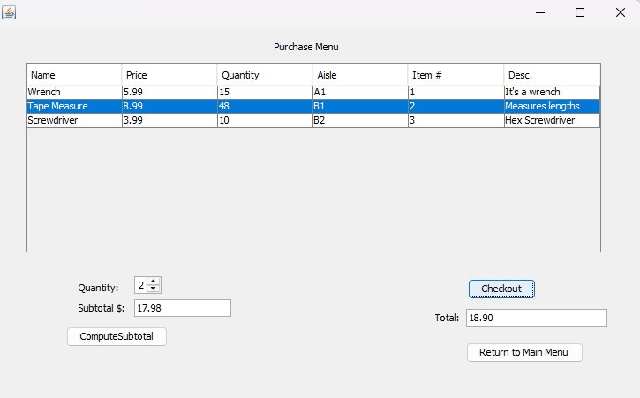

To add an item to your ‘cart’ you can click the item you want to select and then the quantity of that item using the spinner, the changes in quantity will be immediately reflected in the table. Once you select an Item, you click compute subtotal to save the price and can then select other items to add. Once you are finished, you can use the checkout button to display the final total.

Store Info Menu:

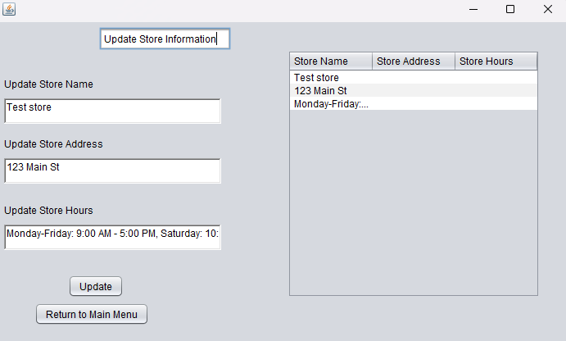

The store info menu consists of a Table which gets data from store info csv file. It consists of three options to update store name, store address, and store hours.

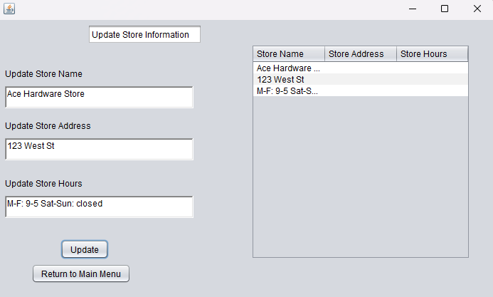

The user would type which attributes they want to change in the store information and click the update button. The changes will be reflected in the table and in the csv file.